|  |  |  |
| --- | --- | --- |
| CREATE SEQUENCE day_5  INCREMENT 5  MINVALUE 0  MAXVALUE 100  START 10  CYCLE; | CREATE TABLE IF NOT EXISTS brands (  idbrands INT NOT NULL,  name_brand VARCHAR(45) NULL,  PRIMARY KEY (idbrands)); | CREATE TABLE IF NOT EXISTS clients (  idclient INT NOT NULL,  FIO VARCHAR(45) NULL,  pasport VARCHAR(10) NULL,  adress VARCHAR(45) NULL,  tel VARCHAR(10) NULL,  PRIMARY KEY (idclient)); |
| CREATE TABLE IF NOT EXISTS films_on_scassettes (  cassettes_idcassette INT NOT NULL,  films_idfilms INT NOT NULL,  PRIMARY KEY (cassettes_idcassette, films_idfilms),  FOREIGN KEY (cassettes_idcassette)  REFERENCES cassettes (idcassette)  ON DELETE NO ACTION  ON UPDATE NO ACTION,  FOREIGN KEY (films_idfilms)  REFERENCES films (idfilms)  ON DELETE NO ACTION  ON UPDATE NO ACTION); | CREATE TABLE IF NOT EXISTS cassettes (  idcassette INT NOT NULL DEFAULT nextval(day_5),  describtion TEXT NULL,  sticker TEXT NULL,  brands_idbrands INT NOT NULL,  price_1_day INT NULL,  price_3_day INT NULL,  price_1_week INT NULL,  available INT NULL,  total_recording_duration(min) INT NULL,  PRIMARY KEY (idcassette),  FOREIGN KEY (brands_idbrands)  REFERENCES brands (idbrands)  ON DELETE NO ACTION  ON UPDATE NO ACTION); | CREATE TABLE IF NOT EXISTS clients_has_cassettes (  order_id INT NULL PRIMARY KEY,  clients_idclient INT NOT NULL,  cassettes_idcassette INT NOT NULL,  date_out DATE NULL,  date_in DATE NULL,  total_price INT NULL,  FOREIGN KEY (clients_idclient)  REFERENCES clients (idclient)  ON DELETE NO ACTION  ON UPDATE NO ACTION,  FOREIGN KEY (cassettes_idcassette)  REFERENCES cassettes (idcassette)  ON DELETE NO ACTION  ON UPDATE NO ACTION); |
|  | CREATE TABLE IF NOT EXISTS films (  idfilms INT NOT NULL,  name_film VARCHAR(45) NULL,  duration(min) INT NULL,  category VARCHAR(45) NULL,  theme VARCHAR(20) NULL,  country VARCHAR(20) NULL,  filmcompany VARCHAR(45) NULL,  describtion TEXT NULL,  director VARCHAR(45) NULL,  actors VARCHAR(120)[] NULL,  PRIMARY KEY (idfilms)); |  |

Мамонов Антон 3ИСиП-19-1

Создаем базу данных, при этом нужно учесть объектно-реляционных связи, ограничения в таблицах, массивы, последовательности.

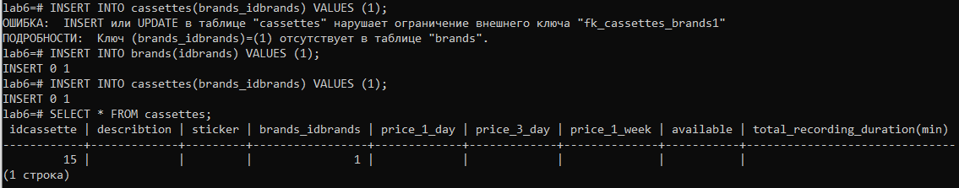

Ограничения и последовательности работают

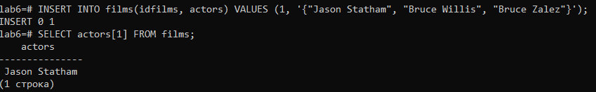

Теперь массивы

Экспорт

Импорт

